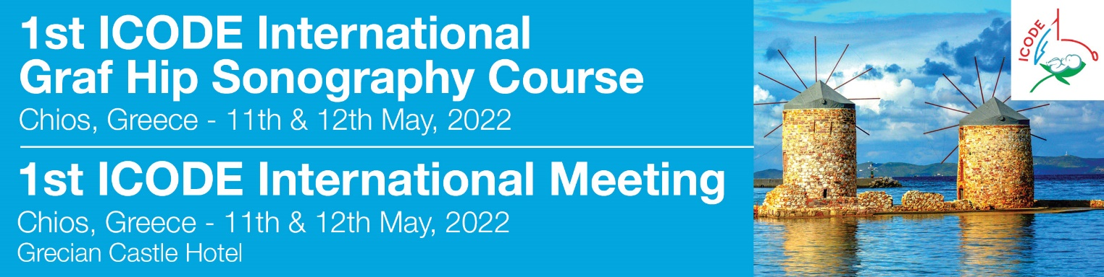

ACCOMMODATION FORM
please send this form to MikaTravel
For further information regarding your accommodation please contact: Mrs Eva Gouvianaki MikaTravel - e mail: congress@mikatravel.eu Tel.: + 30 2810223356

Mr /Mrs
Last Name/First Name:
Tel.: | Mobile:
e-mail:
Accompanying person: Mr Mrs

Name:

GRECIAN CASTLE suggested hotel
Price per day Price includes

Single room 82 €
Double room 95 € Bed & Breakfast
Overnights from __________ to _________ Total overnights ___________
TOTAL for accommodation or DEPOSIT ------------------ €
For confirmation a deposit of minimum 1 night is necessary

METHOD OF PAYMENT

By Bank transfer to the order of DIMITRA MYKONIATI – MIKA TRAVEL
(please enclose a copy of the bank transfer. Please state your name and Congress title on the bank transfer)
EUROBANK ERGASIAS
IBAN:GR4902600200000110201259910
BIC: ERBKGRAAXXX
Account Name : Dimitra Mykoniati (Mika Travel)
If you wish to pay by credit card, please contact us.

