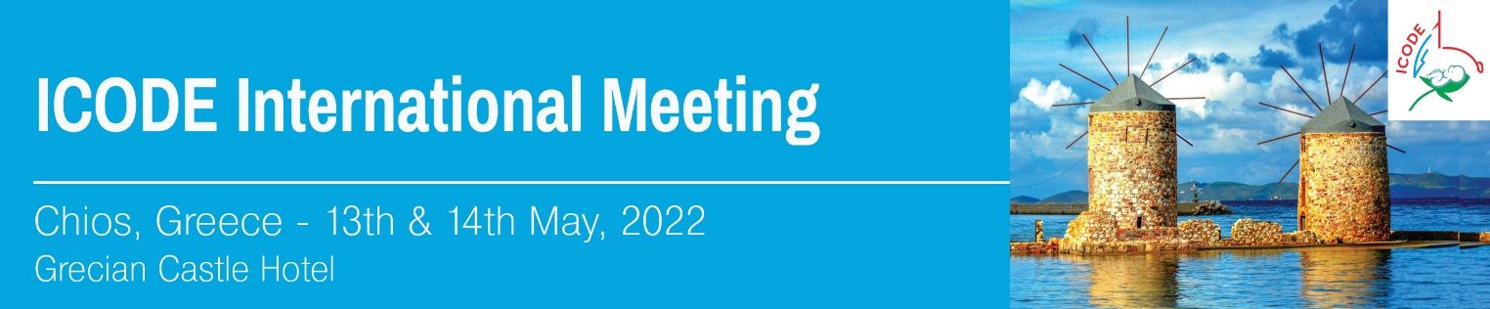

REGISTRATION FORM

please send this form to MikaTravel

For further information regarding the registration please contact:
Mrs Eva Gouvianaki - MikaTravel
Email: congress@mikatravel.eu Tel.: + 30 2810223356

Mr /Mrs

Last Name:
First Name:
Affiliation :

Tel.: | Mobile:
e-mail:

*FREE REGISTRATION

