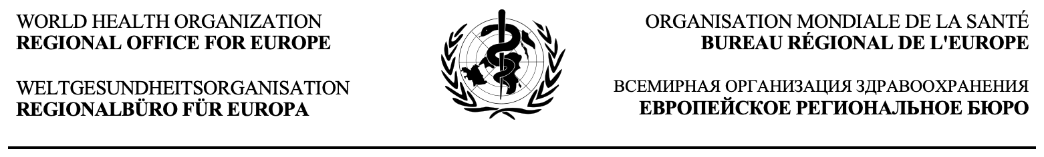
WHO Initiative for the Elimination of Cervical Cancer: Insights for a successful implementation in Greece  Round Table Discussion  Date: December 6^{th,} 2024  Venue: Divani Caravel Hotel, Athens  Format: Hybrid (In-Person and Virtual Participation via Zoom) | Original Language:  Greek and English

Preliminary Agenda
08:30 – 9:00 | Registration and Welcome
09:00 – 09:45 | Opening  - João Breda, Head, WHO Athens Quality of Care and Patient Safety Office, Special Representative & Officer in Charge, WHO Greece (WHO QoC)  - Fofo Kalyva, Secretary General of Public Health, Ministry of Health, Greece  - Aspasia Plakantonaki, UNICEF Deputy Representative in Greece  - Theodoros Agorastos, Emer. Prof. of Obstetrics and Gynecology, Aristotle University of Thessaloniki, President of Hellenic HPV Society
09:45 – 10:30 | Introduction  Chair: Siff Malue Nielsen, Technical Officer, WHO/EUROPE  - The WHO call to eliminate Cervical Cancer  Marilys Corbex, Senior Technical Officer, WHO/EUROPE  - Keynote: Greece on the Way to Achieve the WHO Cervical Cancer Elimination Targets  Silvia de Sanjosé, MD, PHD Associated researcher ISGlobal, Spain & Consultant USA NCI  - Q&A
10:30 – 11.00 | Coffee Break

11:00 – 12:30 | Panel Discussion: HPV Vaccination – Challenges and Opportunities  Chair: Martin Weber, Team Lead, Quality of Care, WHO Athens Quality of Care and Patient Safety Office  - Flora Bacopoulou, Prof. of Pediatrics-Adolescent Medicine-Clinical Pharmacology, Head of Center for Adolescent Medicine, UNESCO Chair Adolescent Health Care, Medical School, NKUA  - Zenia Saridaki, Medical Oncologist, President of the Hellenic Society of Medical Oncology (HeSMO), Director at the 1st Oncology Dept. Metropolitan Hospital, Athens, Scientific Director of the Oncology Department "Asklepios DIAGNOSIS”, Heraklion Crete, Greece  - Paraskevi Mihalopoulou, Vice President of the Hellenic Cancer Federation (ELLOK), President of the Panhellenic Association of Women with Breast Cancer "Alma Zois"  - Siff Malue Nielsen, Technical Officer, WHO/EUROPE  - Reflection from the audience and plenary discussion
12:30 – 13:30 | Lunch
13:30 – 15:00 | Panel Discussion on Cervical Cancer Screening Issues in Greece  Chair: Marilys Corbex, Senior Technical Officer, WHO/EUROPE  Co-Chair: João Breda, WHO QoC  - Theodoros Agorastos, Emer. Prof. of Obstetrics and Gynecology, Aristotle University of Thessaloniki, President of Hellenic HPV Society, Thessaloniki  - Konstantinos Athanasakis, Ass. Prof. of Health Economics, University of West Attica, Greece  - Marc Arbyn, Coordinator of the Unit of Cancer Epidemiology, Belgian Cancer Centre, Scientific Institute of Public Health, Brussels, Belgium (virtual)  - Maribel Almonte Pacheco, Implementation Scientist, WHO  - Reflection from the audience and plenary discussion
15:00 – 15:15 | Coffee Break
15:15 – 16:30 | Panel Discussion: Treatment and Integration of Palliative Care to Cervical Cancer Care  Chair: Theodoros Agorastos  - John Boukovinas, Medical Oncologist, f. President of the BoD of the Hellenic Society of Medical Oncology (HeSMO), Head of Oncology Unit, Bioclinic, Thessaloniki, Greece  - Theodoros Kalloniatis, Internist, Head of Medical Department of Galilee Palliative Care Unit, Greece  - Julie Ling, Technical Officer (Palliative Care), WHO/EUROPE  - Reflection from the audience and plenary discussion
16:30 – 17:00 | The Way Forward and Closure  - Theodoros Agorastos, Emer. Prof. of Obstetrics and Gynecology, Aristotle University of Thessaloniki, President of Hellenic HPV Society, Thessaloniki, Greece  - João Breda, Head, WHO Athens Quality of Care and Patient Safety Office, Special Representative & Officer in Charge, WHO Greece

